Knowledge Management in Salesforce Service Cloud

Introduction and Overview: Knowledge Management In Salesforce Service Cloud

A strategy for creating, managing, and sharing knowledge for self-service options and efficient agent help is known as knowledge management in the Salesforce Service Cloud.

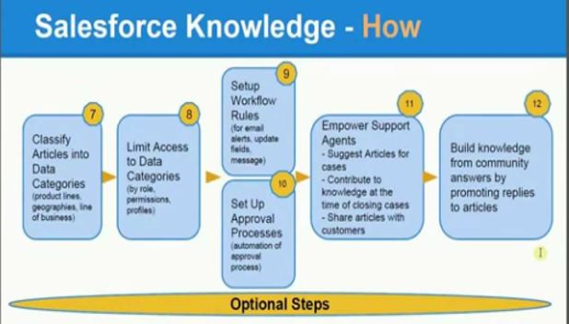
Fig 1

In addition to improved self-service choices and agent efficiency, consumers and agents will have the correct information to resolve issues quickly and effectively with the help of effective knowledge management strategies.

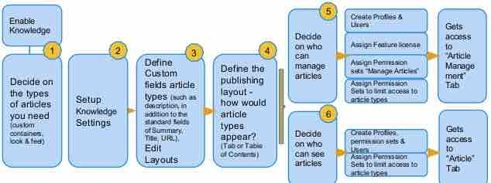

Fig 2

Figures 1 and 2 are flowcharts illustrating the steps involved in creating an article using a knowledge-based system. The process starts with enabling access to a tablet, then progresses through defining custom fields and layouts for the article content, assigning permissions to users, and finally creating and managing the article itself.

Knowledge Management Includes 3 Core Steps Creating Managing and Sharing Knowledge Articles

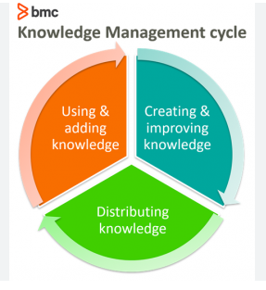
Fig 3
Figure 3 is a Flowchart outlining steps for building a knowledge base article, like creating a recipe with specific details and permissions.

Creating Knowledge Articles

Addressing consumer inquiries and issues in a structured manner is an integral part of producing a knowledge piece. Prior to documenting solutions, it is essential to identify the most common client difficulties.

Then, make sure that the information is presented clearly and straightforwardly so that both customers and support agents can easily understand and implement the solutions. Additionally, it needs to be formatted consistently in Salesforce Service Cloud Editor and adhere to the organizational style guide.

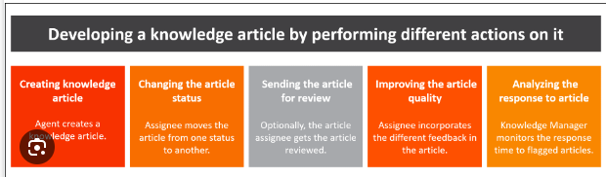
Fig 4

The flowchart, Fig 4, outlines the process of creating and managing knowledge-base articles, including defining content, assigning permissions, and publishing

Knowledge pieces should also be user-friendly. Users need advice on how to fix problems step by step. Additional visual aids like diagrams or screenshots can be supplied in certain instances to enhance comprehension further.

Managing Knowledge Articles

Managing knowledge Articles in Salesforce service Cloud permits organizations to create, organize, and distribute valuable information to dealers and clients. Through leveraging the knowledge Base, companies can offer consistent and correct answers to customer inquiries, enhancing decision instances and customer satisfaction. Functions like versioning, article linking, and analytics allow continuous refinement and optimization of knowledge text, ensuring relevance and effectiveness in assisting service interactions.

Knowledge pieces must be consistently organized and up-to-date in order to be managed effectively. Article categories allow for effective categorization, which in turn makes it easy for users to locate certain content.

Knowledge articles can be made more searchable for specific topics by using appropriate tagging and keyword usage while creating them.

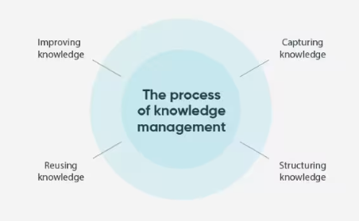

Reviewing and updating knowledge articles is a continual process to ensure they continue to meet consumer needs. Salesforce Service Cloud reviews and tracks changes correctly to keep version control and quality control standards in check.

Because of the application of version control and review processes, the content supplied in knowledge articles is accurate and reliable.

Sharing Knowledge Articles


Fig 5
When knowledge articles are distributed effectively, customers and support agents can benefit from self-service. Customers can access knowledge articles through the Service Cloud Console and self-service portals.

If the self-service portal can be customized to meet the customer's needs, the customer will find the information more easily.

When the search function is improved, everything becomes easy, and articles can be recommended for easy answer discovery. Thanks to the integration of knowledge articles with the Service Cloud Console, efficiency and customer satisfaction can be improved.

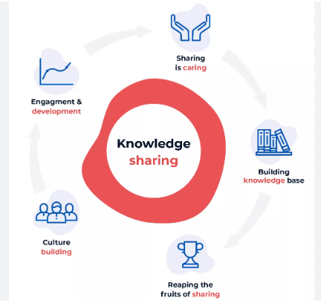

Fig 6

Fig 6 shows a knowledge-sharing process in which knowledge is captured from experts, stored in a central location, and then accessed and applied by others.

It allows agents rapid access to information during client contacts. All of this contributes to the creation of self-service solutions that will enhance the user experience and maintain a smooth customer support process.

Perks and Advantages of Knowledge Management

Basic Benefit of knowledge management:



Using Salesforce Service Cloud for strategic knowledge management can lead to several benefits, such as happier customers, more efficient operations, and faster company growth. The following is an outline of the key advantages in detail:

Better Self-Service Options

The utilisation of thorough self-service alternatives is bolstered by strategic knowledge management. Customers' reliance on support agents is reduced when they have access to enough information in the form of knowledge articles.

Improving self-service in Salesforce service Cloud includes growing a complete information base, optimizing search functionality, integrating AI and chatbots, and leveraging analytics for continuous improvement. These technical enhancements streamline customer access to statistics, enhance user experience, and reduce support prices by way of empowering customers to locate answers independently.

Timely issue resolution boosts customer happiness and decreases support team overload, freeing them to focus on complex inquiries.

Efficiency in Operations

Having relevant knowledge articles readily available equips support agents with the information they need to address consumer inquiries. Due to the very rapid availability, the representatives are able to effectively handle consumer queries by providing them with accurate and comprehensive information.

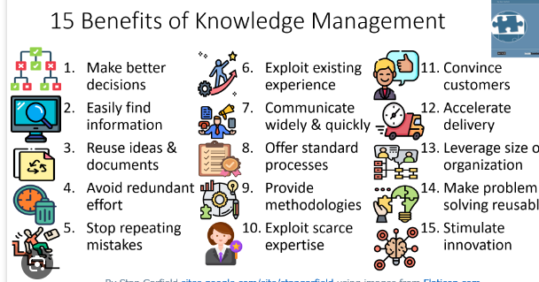

Customers are more satisfied and loyal as a result of the enhanced quality of their interactions and the overall increase in processing time.

Organized And Standardized Information

Thirdly, the material is organised and standardised: knowledge articles are a storehouse of information that is well-written and consistent throughout all interactions with customers.

By following predetermined protocols when writing these pieces as a group, businesses may keep their reputations intact and steer clear of spreading false information. Customers will have faith in the organisation's products and services since the information will be consistent, which is why it is essential.

Compliance and risk control:

Regulatory Adherence: A structured knowledge control system allows businesses to maintain compliance with industry guidelines and requirements by means of making sure that data is correct, up to date, and without difficulty reachable.
Audit Trails: Monitoring changes and access to knowledge articles gives an transparent audit trail, helping in regulatory audits and reducing compliance risks.
Records security: Implementing strong safety features inside the knowledge control system protects sensitive data, making sure records integrity and compliance with records safety guidelines.

Scalability:

Adaptable Framework: Knowledge management structures designed with scalability in thoughts can accommodate developing volumes of records and increasing person bases with out compromising overall performance.
Flexible Integration: Scalable solutions without difficulty combine with different enterprise structures, permitting seamless records float and interoperability across numerous platforms and applications.
Cost- performance: Scalable knowledge control structures provide cost- effective solutions by means of allowing groups to increase their skills incrementally, aligning investment with growth and demand.

Continuous Improvement

In order for organisations to refine their knowledge management procedures, it is essential to examine and update knowledge articles regularly. Organisations may be flexible and sensitive to changing client needs by including feedback, best practices, and developing trends within the articles.

The customer service programmes are generally made more effective by this iterative process, which also creates a culture of continuous improvement and stimulates innovation.

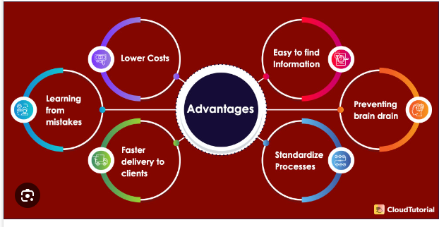
Fig 7

Fig 7 shows an outlining benefits of clinical decision support systems (CDSS) in healthcare, including lower costs, easier information access, and standardized processes.

Trodden Path of Expertise

The trodden path of knowledge refers back to the established and proven strategies, practices, and information collected over time through experience and continuous learning. It represents the attempted-and- real strategies that specialists in an field follow to achieve constant results and resolve complicated troubles correctly.

Knowledge management provides support agents with access to information and expertise that allows them to tackle complex customer concerns successfully. Salesforce Service Cloud's knowledge articles library will enable agents to tap into the organisation's collective wisdom to resolve intricate customer issues efficiently.

As a result, support workers become more knowledgeable and are able to provide proactive and personalised assistance, which ultimately improves the customer experience.

Training Time and Costs

A company's knowledge management and information needs may be better planned, which means less time spent onboarding new support agents.

Training time and costs are essential concerns while implementing new systems like Salesforce service Cloud. Even as initial investments in training packages involve charges for materials and trainer expenses, they're important for reinforcing employee capabilities and enhancing efficiency.
Salesforce Service Cloud's knowledge articles help new employees quickly become up-to-date on corporate policies, products, and procedures, speeding up the onboarding process and reducing training expenses. This enhances the agent onboarding process and fosters uniformity in service delivery throughout the company.

Data-Driven Decision-Making

Knowledge management can lay the groundwork for data-driven decision-making in customer operations, preferences, trends, and behaviour, as well as in other areas.
Organisations can track the effectiveness and utilisation of knowledge articles to find out what needs fixing and how to tweak their knowledge management tactics. Through collecting and analyzing relevant data from numerous sources, corporations can make objective, informed choices that align with their goals and optimize overall performance. This technique fosters continuous improvement, drives increase, and enhances customer satisfaction by using leveraging actionable insights from data, overall this data-driven method helps companies align their knowledge management initiatives with consumer needs and company objectives.

Final Thoughts

Thus, knowledge management in Salesforce Service Cloud is crucial for equipping support agents and clients with the necessary information to provide outstanding service experiences. This could result in improved self-service options, more efficient agent operations, and happier customers, as could the production and upkeep of related articles.

The structured method to knowledge management not only improves self- carrier options but additionally equips support retailers with valuable insights to address complex customer inquiries. This leads to better customer satisfaction, decreased support team overload, and extra efficient operations.

Moreover, leveraging data-driven decision-making alongside knowledge management enables companies to make informed and strategic decisions that align with enterprise goals and customer needs.

